CSC265 Final Project

# **Introduction**

For our project we chose to do a simple local instant messaging application that meets all of the requirements for the project. We felt the best way to accomplish this was to implement the application with java code. The application allows the client and server to message each other over a secure SSL based socket connection.

## **Development Environment**

To make the development of the software more effective and easy, we as a team chose our development environment to be eclipse.

## **Team Members/Responsibilities**

### **Douglas Tolbert-Cooke**

**DEV LEAD**

My name is Douglas Tolbert-Cooke and I am a senior majoring in Computer Science. I am equally knowledgeable in Python as I am Java. However, I've only taken half of each one class wise. I'm currently in a Python class so I guess I'm currently better with Python. I've used IDLE and Eclipse as my programming platforms. I have general networking knowledge but anything I do not understand I can obtain the information.

### **Andrew Rivera**

**QA LEAD**

My name is Andrew Rivera, I'm currently a senior going for a bachelor's degree in Computer science, with a focus in Information systems. I have taken multiple classes using java as a programming language and I feel the most comfortable using that for this project. I also have a semester's worth of experience using python, JavaScript, CSS, html, GUI, and SQL. I use brackets and notepad++ as my development platforms for the majority of the coding that I do. I have a general knowledge in networking but nothing of significance.

### **Linner Rivas**

**SCRUM MASTER**

My name is Linner Rivas, I am currently a senior going for my bachelor’s degree in Computer science focused on Computer Information System. I have my associate in computer information system. I have learned the skills of programming in the basic language in Java, Python, HTML, CSS, JavaScript, C++, C# and I do have a lot of skills base in database(SQL). The development platform that I use a is notepad++ and Visual studio. I have a general knowledge of networking but if I have a problem or I don’t understand, I would google it anything on networking. I work in a IT, networking and development company.

## **Project initial Proposal**

Our groups initial proposal was to create a web-based instant messenger software. In the web-bases IM, the user would be able to login or sign up to the instant messenger. Once the user login or signup, he/she would be able to communicate with another user online. The user would be able to see the friends that they have in the connect and as well they would be able to add an aviator to the IM. So that you know who is the one sending the message. As well with the ability to go back to history log and view the messages.

But Down the line we change the view and our code from web-based instant message to a local, more simple and user-friendly GUI application. The chat has a frame that in the center has the ability to let you know if you are connected, as well it will have the client and server names show up when connected.  The client/server are able to enter their message at the bottom of the screen and press enter in their keyboard. The client/server message would be send quickly.

## **Final Project Design**

#### **List of functionalities provided by your software**

* User friendly GUI
* Start typing
* Enter to send
* To end type “END”

#### **System model:**

#### **Our system model is running a Client/Server. The Encryption method that was created is SSL. Which the SSL is completely secure and any data or text that is send on the chat cannot be access from anyone outside of the chat.**

## **Implementation**

**Mac OS:**

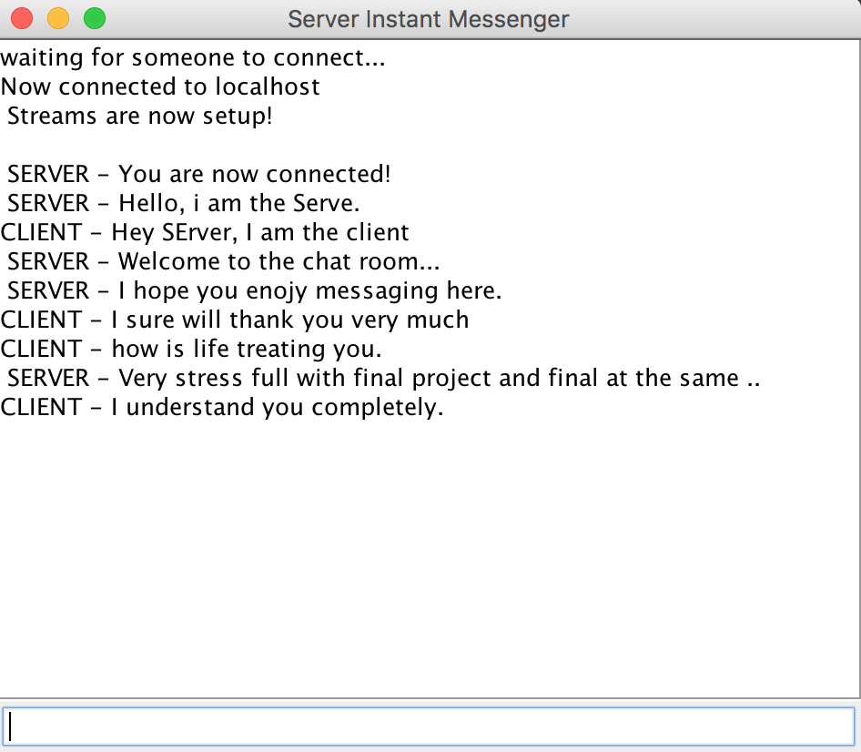

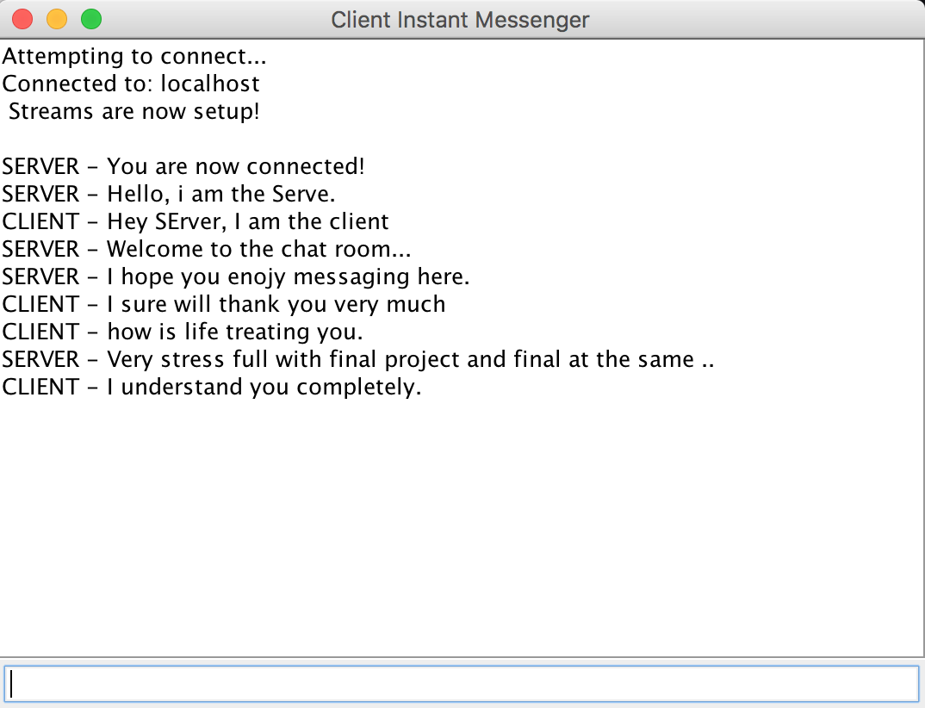

**Window OS:**

